Given a rows x cols binary matrix filled with 0's and 1's, find the largest rectangle containing only 1's and return *its area*.

**Example 1:**

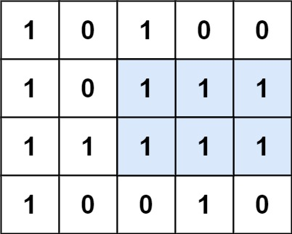

Input: matrix = [["1","0","1","0","0"],["1","0","1","1","1"],["1","1","1","1","1"],["1","0","0","1","0"]]  
Output: 6  
Explanation: The maximal rectangle is shown in the above picture.

**Example 2:**

Input: matrix = [["0"]]  
Output: 0

**Example 3:**

Input: matrix = [["1"]]  
Output: 1

**Constraints:**

* rows == matrix.length
* cols == matrix[i].length
* 1 <= row, cols <= 200
* matrix[i][j] is '0' or '1'.